Verification is related to formal proof of correctness and validation is a technique that increases confidence in correctness.
What is testability
Testability verifies correctness of manufactured hardware, it is a manufacturing test. The chip must be exercised to demonstrate that no manufacturing defects render the chip useless.
Test Procedure:
Classification of manufacturing test
Manufacturing test fall under number of categories depending upon intended goal:
- Diagnostic test: It is used in chip debugging or board debugging and tries to detect falling part, identify and locate the offending faults.
- Functional Test: This is also called as go/no go test or production test. It determines whether the component is functional or not. As this test must be executed on every manufactured die and has a direct impact on the cost, it must be simple and shift as possible.
- Parametric test: it checks on a number of parameters of the design under variety of working conditions, this requires different setup from the others where the signals of 0 or 1 has to be considered. They are divided as static (DC) and dynamic (AC) tests.
Typical Manufacturing process takes places as follows:
- The predefined test patterns are loaded into the tester that provides excitation to device under test (DUT) and collects the corresponding responses.
- The test pattern are defined in a test program (e.g. test bench in VHDL) that describe the waveforms to be applied, voltage levels, clock frequency and expected response.
- A new part is fed automatically into the tester. The tester executes the test program, applies the sequence of the input pattern to the DUT and compares the obtained response with expected one.
- If difference in output is observed, the part is marked as faulty and the probes are automatically moved to next die on the wafer. During the scribing process that divides wafer into dies spotted parts will automatically discarded.
- In the last step the DUT is removed from the testing board and placed into the good or faulty bin depending upon the outcome of the output. The entire process is completed in few seconds and thus making it possible for the tester to handle thousands of parts in an hour.
Define Testability
Design for Testability:
The inclusion of this concept means the provision of for setting or resetting the key nodes in a system and then observing the response at key points in the system. Design for testability is just a set of design rules or guidelines which if obeyed will facilitate test. Any failure occurring during testing is attribute either poorly controlled fabrication process or to a design defect.
Testing procedure of any system is required to be well set-up. In this combination and/or a sequence of binary values are applied at the inputs of the device under test (DUT) in the form of a test pattern or test vector. Finalization of the specification of the test vector sequences is done in consultation with the designer while generation and application of test pattern to a DUT are activities performed by the engineer.
Automatic Test patterns (ATPG) generation are employed to expedite testing, but they are complicated to use properly and tend to be costly on circuit size increases. On the occurrence of any fault after the application of test pattern, diagnosis is undertaken to localize the fault.
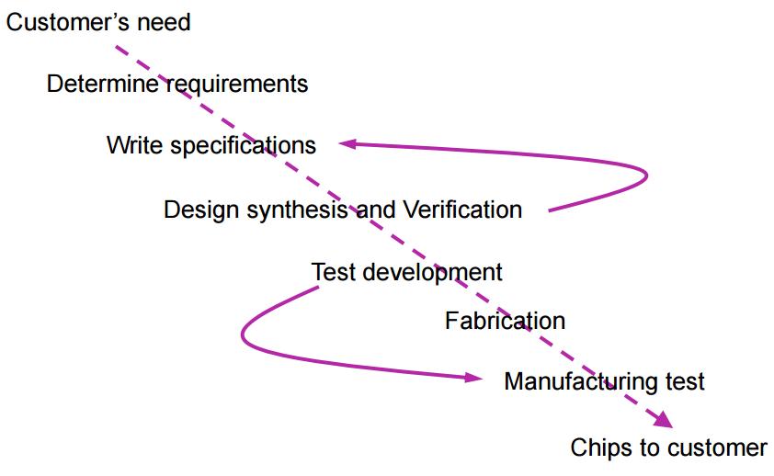
Explain Issues in design for Testability
Issues in design for Testability:
Combinational and sequential circuits under test:
- Combinational devices under test (CDUT):
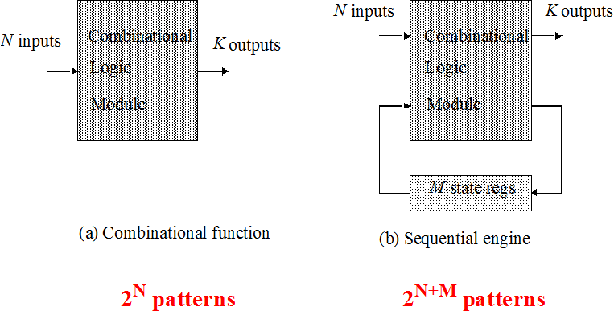
The correctness of the combinational logic modules can be validated by exhaustively applying all possible input patterns and observing the responses. A circuit having N inputs has 2^{N} input combination which can be generated by N-bit counter to satisfy controllability and then observe the outputs and check for observability. But this is possible only when N is comparatively small. If the application and observation takes 1μsec, the total tests of the module 1 sec if combinations are 1 million.
Number of inputs (N) | Input combination | Total Test time
20 inputs | 2²⁰ | 2²⁰ x 10⁻⁷≥ 7 minutes
40 inputs | 2⁴⁰ | 2⁴⁰ x 10⁻⁷≥ 30 hours
64 inputs | 2⁶⁴ | 2⁶⁴ x 10⁻⁷≥ 57400 years
Therefore test times are highly impracticable and hence other techniques are used for testing cause as the number of inputs increase the time requirement is more.
- Sequential Device Under test (SDUT):
The outputs of the circuit depend not only upon the inputs applied and also upon the values of the previous state. To test this finite machine state (FSM) requires the application of 2^{M+N} input patterns; where M is no of state registers and N is the number of inputs.
There are m feedback variables that make the state vector and decide the maximum number of the finite states that the circuit can assume. Usually, the next state the machine would assume and its output are both functions of current state and independent inputs. Generally, the delay elements are associated with the feedback path. In case of clocked or synchronous the delay elements are flip-flops while in synchronous they may be due to circuit propagation delays. The generation of the test signals/ test patterns is not very easy because they not only have to be logically correct, but also occur at correct time with respect to other signals.
An alternative approach is required as the above two are not possible if the number of inputs increase, a more feasible testing approach is based on:
- An exhaustive enumeration of all possible input patterns contain a substantial amount of redundancy i.e. single fault in the circuit covered by a no. of input patterns.
- A substantial reduction in the number of patterns can be obtained by relaxing the condition that all faults must be detected so test procedures only attempt 95%-99% fault coverage.

Explain controllability and observability
Design for test (DFT) approach is one of the tests employed for combinational logic is:
- Controllability:
  - It measures the ease of bringing a circuit node to a given input pin and a node can easily be controllable, if it can be bought to any condition with only a single input vector.
  - A single node (or circuit) with low controllability needs a long sequence of vectors to be bought to a desired state.
  - A high degree of controllability is desirable to test design. Controllability refers to the ability to apply test patterns to the inputs of sub-circuit via primary inputs; it is present at the input side.
- Observability:
  - It measures the ease of observing the value of a node at output pins. A node with high observability can be monitored directly on the output pins
  - A node with low observability needs a number of cycles before its state appears on the outputs.
  - A complex circuit with limited number of output pins, a testable circuit should have high observability.
  - Observability refers to the ability to observe the output response of a sub circuit via primary outputs.
In combinational circuits any node can be controlled and observable in a single cycle.
Explain different types of Design Approaches for Sequential Modules
Design Approaches for Sequential Modules:
- Ad Hoc testing:
  - It combines a collection of tricks and techniques that can be used to increase the observability and controllability of a design that are applied in a dependent fashion.
  - Design for low testability. It is a simple processor with its data memory is only accessible through the processor. Writing and reading of data value in and out of a single memory position requires a number of clock cycles
  - The controllability and observability of memory can be dramatically improved by adding (select lines) multiplexers on the data and address bus as shown in the above figures.
  - During normal operation mode, these selectors direct the memory ports to the processor. During Test Mode the data and address ports are connected directly to I/O pins and testing the memory can proceed more efficiently.
  - Ad Hoc testing approach also includes the portioning of the machines, addition of extra test points, provision of reset states and introduction of test buses and most of the approaches depend upon application and architecture.

- Scan Based Test (Serial Scan List):
Objective:
            - Simple Read/Write access all or subsequent storage elements in a design
            - Direct control of storage elements to an arbitrary value (0 or 1)
            - Direct observation of storage elements and hence internal state of circuit.
The registers are modified to support two operation modes:
- In normal mode they act as a N-bit wide clocked registers
- In test mode the registers are chained together as single shift register
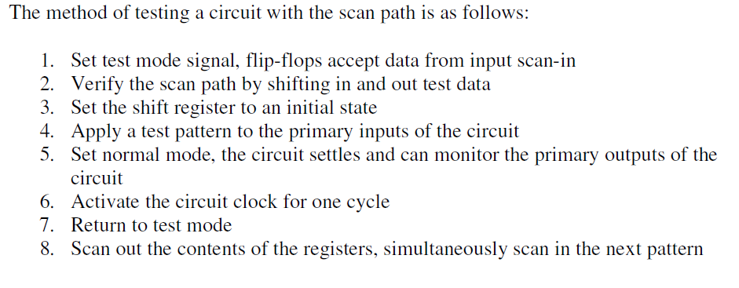Advantages:
- This approach gives a minimal overhead
- The serial nature of the scan chain reduces the routing overhead
- Enhanced controllability and observability
2a)Level Sensitive Scan Design (LSSD):
Level sensitive means that the sequential network is designed so that when input change occurs the response or output is independent of the component and wiring delays with network.
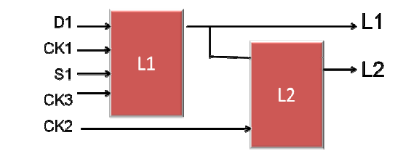
FIGURE: LSSD CONFIGURATION
Here clock 1 and 2 (CK1 and CK2) control normal operation and CK3 and CK2 control scan path movements through SRL (shift register latches) L1 and L2 and D1 is the normal data input pin. S1 is the scan data pin.
The level sensitive aspect means that the sequential network is design so that when an input changes occurs, the response independent of the component and wiring delays within the network. It consists of two latches L1 and L2.
In normal operation mode signal D1,L1, CK1 serves as latch input, output and clock respectively. CK2 and CK3 are low in this mode
In scan mode S1, SO serves as scan in and scan output respectively. CK1 is low during this interval and CK2 and CK3 are non-overlapping two phase test clocks.

Advantages:
- The circuit operation is independent of the dynamic characteristics of the logic elements- rise and fall time and propagation delays
- ATP generation is simplified since the tests need only be generated for a combinational circuit
- LSSD methods, when adopted in design, eliminate hazards and races so, greatly simplifies test generation and fault simulation
2b)Boundary Scan Test (BST) Industry Standards:
It is design under test (DUT) technique for PCB design and Board Testing.
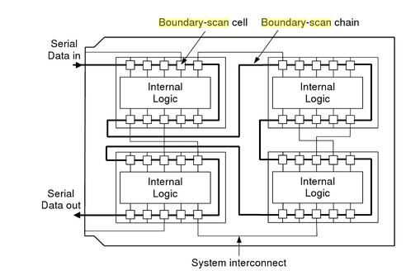
This is a technique involving scan path and self-testing to resolve the problems associated with the testing boards carrying VLSI circuits and/or surface mounted devices (SMDs), Printed circuit boards (PCBs) are becoming very dense and complex, so most test equipment cannot guarantee a good fault coverage.
Boundary scan is standardised to ensure compatibility between different vendors (e.g. .IEEE 1149). It connects the input-output pins of the components on a board into serial data chain. During normal operation the boundary scan pads acts as normal input output devices. In test mode, vectors can be scanned in and out of the pads providing controllability and observability at the boundary of the components. Various control modes allow for testing the individual components as well as board components.
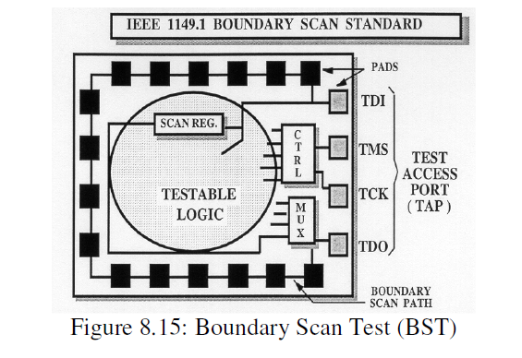
Boundary scan is accessed through five pins:
TCK: test clock
TMS: test mode select
TDI: test data in
TDO: test data out
TRST*: test reset (optional)
Merits of Boundary Scan Check:
- Increased fault coverage system
- The boundary scan check is much more time efficient i.e. time required is less as compared to other systems
- The process of boundary scan is very simple
- In built scan path and self test makes it more accurate and efficient
Boundary Scan Standards:
Their prime objective is to ensure testing and development less costly and efficient. Some of the boundary scan standards are mentioned below:
- Joint Test Action Group (JTAG 1988) mainly used.
- Element test and Maintenance (ETM VHSIC)
- VHSIC Test and Maintenance [TM] Bus Standard
- Testability Bus Standard (IEEE 1989J/IEEE 1149.1) one of the commonly used.
2c) Other scan techniques design:
- Random Access Scan:
  - No shift registers with flip flops
  - Matrix of flip flop addressed controlled and observed
  - No input-output pins
- Partial Scan:
  - In partial scan mode all the flip flops are not into a scan path.
  - The gate overhead is significantly lower partial scan. Also it improves the fault coverage and fault efficiency to high levels
Scan Path:
  - Involves specialized flip flop or latch allowing data to be scanned in for control and then out for observation and then activated in scan mode for test purpose
  - A scan path is tested by special pattern through the scan path before the stuck at faults begins. The test pattern consists of 1s and 0s that test the ability to scan path to shift all possible transitions.
  - Advantages of scan path:
    - Test pattern can be generated automatically using ATPG.
    - No need of complex test vector generator for all inputs except for scan in and scan out.
  - Disadvantages of scan path:
    - Additional multiplexers required.
    - Speed degradation may be observed due to additional multiplexers in signal path.
3)BIST (Build In Self Test):
In this approach testability is having the circuit itself generate the test pattern instead of requiring an application of external patterns.
The objectives of BIST are:
- To reduce test pattern generation cost
- To reduce the volume of test data
- To reduce test time
BIST techniques aim to effectively integrate an automatic test system into the chip design.
BIST is a set of structured test techniques for combinational and sequential logic, memories and multiplexers and other embedded logic blocks. It contains a means for supplying test patterns to the DUT (device under test)/ sub-circuit under test and a means of comparing the device’s response to a known correct sequence. There are many ways to generate pattern:
- Exhaustive approach:
The test length is 2^{N}, N is the no. of inputs to the circuit. In exhaustive nature of the test means that all detectable faults will be detected given the space of the available input signal. Ex: N-bit counter
- Random Approach:
It implies the application of a randomly chosen sub set of 2^{N} possible input patterns. But the subset has to be chosen such that reasonable fault coverage is obtained. Ex: Pseudo random pattern generator.

Explain Linearfeedback Register in detail
Linear Feedback Shift Register (LFSR) [stimuli generator in the figure above]:
This is a part of BIST it consists of serial connection of 1 bit registers. Some of the outputs are XOR and fed back into the circuit. An N-bit LFSR cycles through 2^{N-1} states before repeating the sequence, which produces a random pattern. LFSR model is that of finite state machine comprising storage elements and modulo two adders (XOR Gates) connected in feedback loop. LFSR techniques can be applied in a no. of ways. LFSR can either be series or parallel the differences being in the operating speed and in the area of silicon occupied parallel LFSR being faster.
The final component of BIST being comparator(Compact Test).
It is a signature analysis test. It is cheaper technique to compress the response; it is a comparison between the generated response and expected response stored in on-chip RAM. It compresses the response before comparing them, storing the compressed response of the correct circuit requires only a minimal amount of memory. Any statistical circuit properly distinguishes between bad and good signature.
The response analyser consists of circuitry that dynamically compress the output of the circuit under test (CUT) and a comparator. The compressed output is called the signature of the circuit. And overall approach is dubbed signature analysis. The circuit cunts the number of 0 to 1 and 1 to 0 transitions in the input stream and then compared this count with the count obtained from stimulation module.
Analysis
Compaction Signature
Device Under test (DUT)
Digital Tester

Advantages of BIST:
- Low cost
- High quality testing
- Faster fault detection
- Reduced maintenance and repair cost
Disadvantages of BIST:
- Reduced access time
- On-chip testing hardware can fail
- Additional Silicon area and fabrication processing requirements for BIST

Explain TPG (Automatic Test Pattern Generation):
ATPG (Automatic Test Pattern Generation):
It is a process to determine a minimum set of excitation vectors that cover a sufficient portion of the fault set as defined by the adopted fault model. One possible approach is to start from a random set of test patterns. Fault simulation then detects the number of faults detected. The derivation of minimum test-vector set for more complex circuit is substantially more complex. A number of excellent approaches to address this problem have been developed. For example the D and PODEM algorithm which underlie many current ATPG tools. It thus correct to say that ATPG is currently in the mainstream design automation and powerful tools are available.
The effectiveness of ATPG is measured by the amount of modelled defects, or fault models, that are detected and the number of generated patterns. ATPG is influenced by the fault model under consideration, the type of circuit under test (full scan, synchronous sequential, or asynchronous sequential), the level of abstraction used to represent the circuit under test (gate, register-transfer, switch), and the required test quality.
The ATPG process for a targeted fault consists of two phases: fault activation and fault propagation.
- Fault activation establishes a signal value at the fault model site that is opposite of the value produced by the fault model.
- Fault propagation moves the resulting signal value, or fault effect, forward by sensitizing a path from the fault site to a primary output
What are the different types fault models
Fault models (Mostly problems asked in the question paper):
A model for how fault occur and their impact on circuits is called a fault model. A fault model for every circuit is proposed before actual testing.
Two popular fault models are:
- Stuck at faults
- Stuck open or stuck short faults
The stuck at faults are simpler and popular. At open stuck or stuck short model is more close to real behaviour of circuit but it is difficult to incorporate.
Stuck-at faults:
- Stuck-at faults model assign a fixed value (0 or 1) to signal line in the circuit, which is an input or output of gate/flip flop. Popular forms of stuck-at faults are- single stuck-at faults two fault per line (stuck-at-1, stuck-at-0).
- The properties the fault models must possess are as under:
  - the model must correspond to real faults
  - the model must have adequate granularity
  - the model must be accountable
  - the model must be automated
- The stuck-at fault model even though corresponds to real faults but it does not represent all possible faults.
- Granularity means resolution at which model represents the faults. A fault model with fine granularity is more useful than a model with a coarse granularity
- The fault models can be deduced from by using basic circuits such as AND, OR, Inverter and tri-state buffer.
- Stuck-at faults occur due to shorting of gate oxide (NMOS gate to GND or PMOS gate to V_{DD}) or metal to metal shorts.
Bridging Faults:
A short circuit between two signal lines is called bridging faults. Bridging to V_{DD} or V_{ss} is equivalent to stuck-at fault model. Traditionally both signals after bridging were modelled with logic AND or OR of both signals. If one driver dominates the other driver in a bridging situation, the dominant driver forces the logic to the other one; in such case a dominant bridging fault is used. To better reflect the reality of CMOS VLSI devices, a Dominant AND or Dominant OR bridging fault model is used.
Ex.
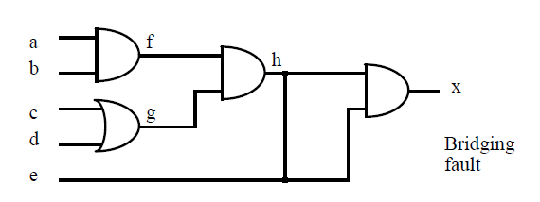

Problems on stuck at models

